Work With Power BI Visuals
Add Visualization to Your Report
Visuals allow you to
present the important information and insights that you discovered in the data in a compelling and insightful way

Report consumers rely on these visualization as a gateway to the underlying data.

Each visual is represented by an icon in the Visualization pane

The type of visuals include:
- Charts
- Maps
- Cards
- A table
- A matrix
- Many more..

An example scenario:
You want to add a visualization to the report that displays the sales data by category name
=> You do this by first, selecting the Category and Revenue fields in the Fields pane,
=> Power BI then automatically selects a visualization for you, depending on the data type of the fields that you selected

NOTE: You can change the visual by selecting the visual, and then selecting a different visualization from the Visualization pane

Choose an Effective Visualization
Power BI offers a range of out-of-the-box visualization options that are available directly from the Visualizations pane

You can experiment with other visualizations to determine which visual best fits your need.
If you CANNOT find one that meets your needs
=> Download other visuals from Microsoft AppSource
=> Import your own custom visual

It is important that you select an effective visualization that displays the data in the best way possible, the following section outlines the different types of visualization that are available:

Table and Matrix Visualization
Table
A grid that contains related data in a logical series of rows and columns

Supports two dimensions

Can contain headers and a row for totals

An example is shown below:

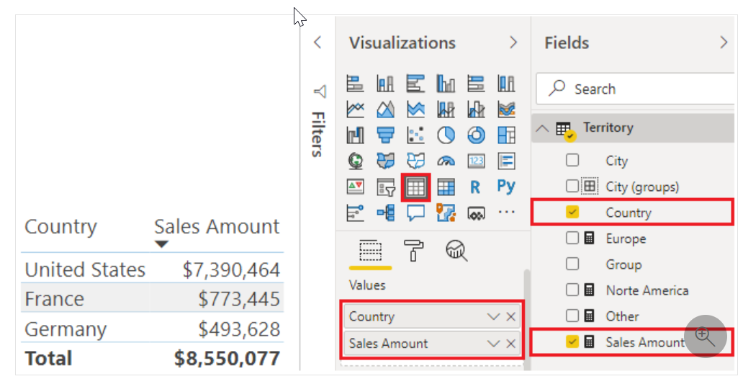
Matrix
The Matrix visualization looks similar to the table visualization

However, it allows you to select one or more elements (rows, columns, values) in the matrix to cross-highlight other visuals on the report page

An example is shown below
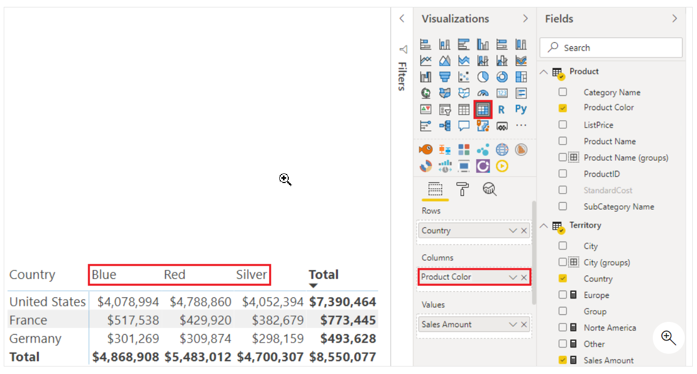
Bar and Column Charts
used to present specific data across different categories in a stacked or clustered format

The stacked format will stack the information items on top of each other
An example is shown below:
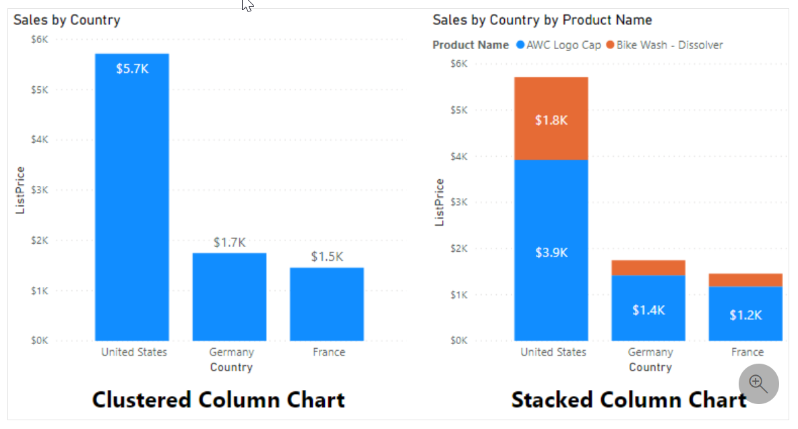
Line and Area Charts
The line chart and area chart visualization are beneficial in helping you present trends over time

The main difference these two chart types is that:
- the area chart highlights the magnitude of change over time – with the area between axis and line filled in

An example is shown below:
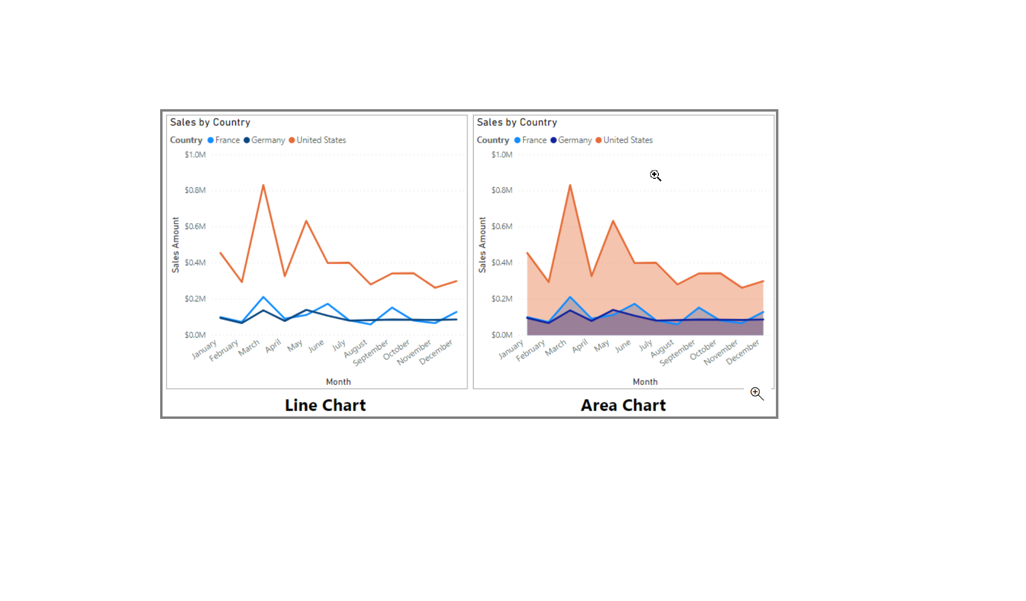
Pie Chart, Donut Chart, and Treemaps
these visualization shows you the relationship of parts to the whole by dividing the data into segments

From a data analysis perspective, these charts are not useful because interpreting the data that they present can be difficult
These charts are best suited for illustrating percentages
such as, top five sales by product or country, or any other available categories

An example of a pie chart and a donut chart is shown below:
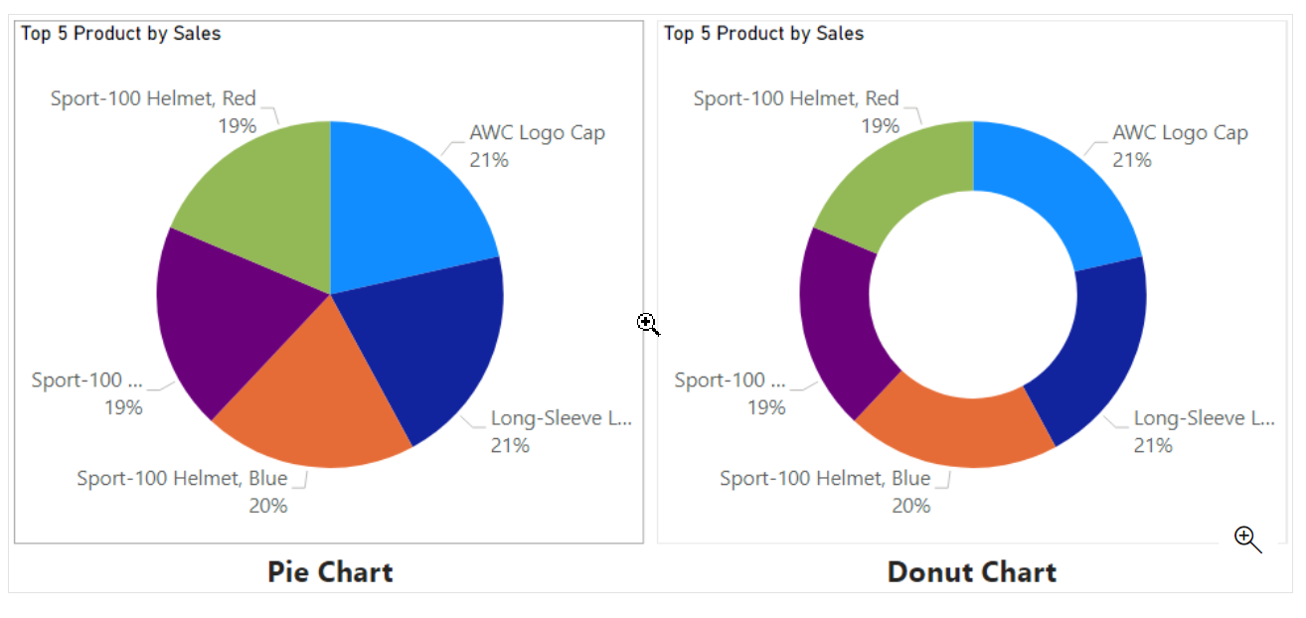
Pie charts and donut charts present data by dividing it into slices,
Too many categories and it results in thin slices (or rectangles) that provide no added
value to the user

Treemap
displays data as a set of nested rectangles

Each level of the hierarchy is represented by a coloured rectangle (branch) containing smaller rectangles (leaves)

The space inside each rectangle is allocated based on the value that is being measured

The rectangles are arranged in size from top left (largest) to bottom-right (smallest)
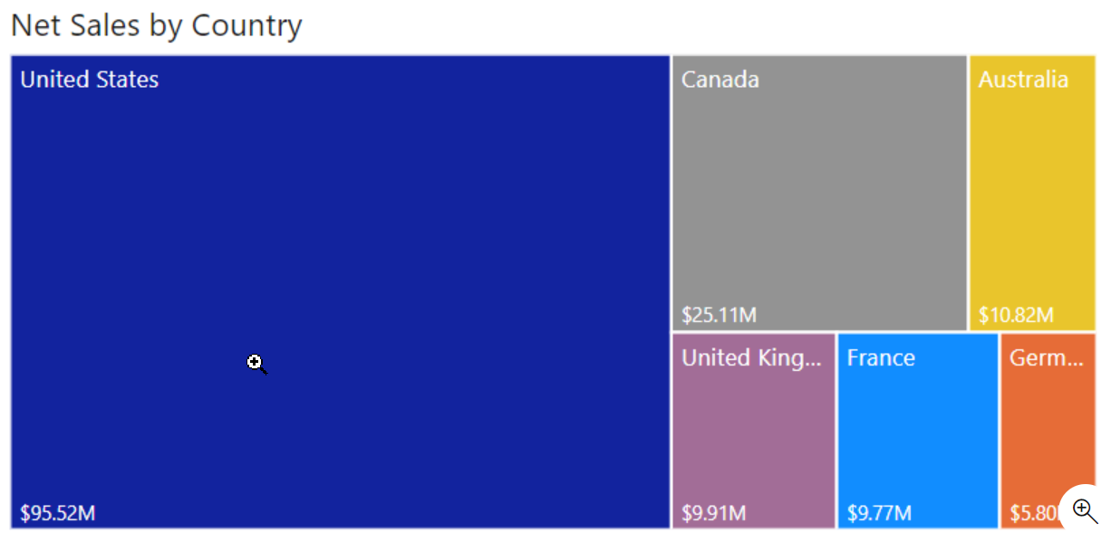
A tree-map is ideal to visualize:
- Large amounts of hierarchical data when a bar chart can’t effectively handle the large number of values
- Proportions between each part and the whole
- The distribution pattern of the measure across each level of categories in the hierarchy
- Attributes, by using size and colour coding
- Spot patterns, outliers, most-important contributors, and exceptions

Combo Charts
A combination of a column chart and a line chart that can have one or two Y axes

The combination allows you to:
- compare multiple measure with different value ranges
- illustrate the correlation between two measures in one visual
- identify whether one measure meets the target that is defined by another measure
- conserve space on your report page

An example is shown below:
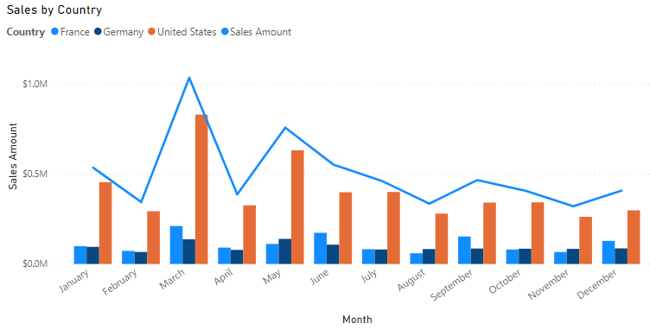
Card Visualization
displays a single value: a single data point

ideal for visualizing important statistics that you want to track on your Power BI dashboard, or report, e.g.,
total value
YTD sales
year-over-year change

The multi-row card visualization displays one or more data points, with one data point for each row

An example is shown below:

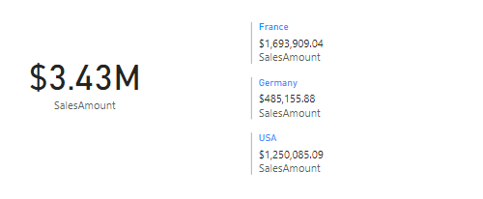

Funnel Visualization
Displays a linear process that has sequential connected stages, where items flow sequentially from one stage to the next

Most often seen in business or sales context

For example:
they are useful for representing a workflow, such as moving from a sales lead to a prospect, through to a proposal and sale

An example is shown below:
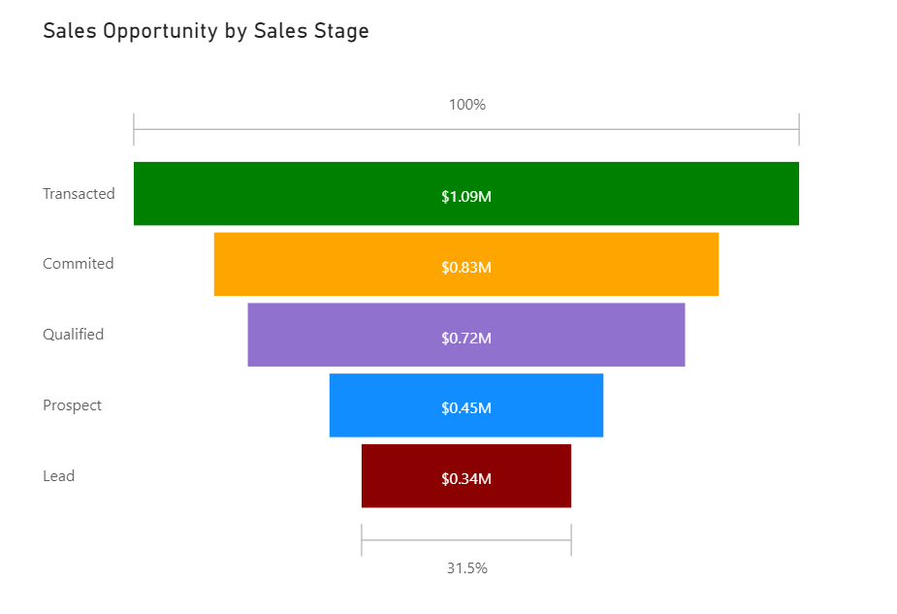
Funnel charts are great options in the following context:
- When data is sequential and moves through at least four stages
- When the number of items in the first stage is expected to be greater than the number of items in the final stage
- To calculate a potential outcome (revenue, sales, deals, and so on) by stages
- To calculate and track conversion and retention rates
- To reveal bottlenecks in a linear process

Gauge Chart
A gauge chart has a circular arc and displays a single value that measures progress towards a goal or target

The value at the end of the arc represents the defaulted maximum value, which will always be double the actual value

In order to create a realistic visual, you should always specify each of the values.

This can be done by dropping to the correct fields:
- Target value
- Minimum value
- Maximum value

into the Visualization pane

An example is shown below:
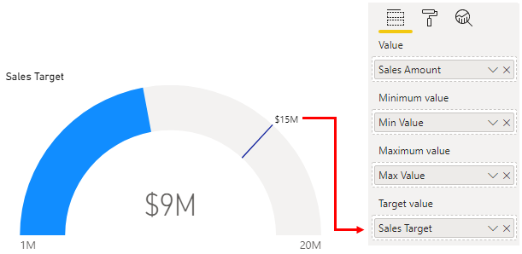
Radial gauges can be used to show the progress that is being made towards a goal or target, or they can show the health of a single measure

However radial gauges take up a lot of space, it is more effective to use a pair of gauges with a spark line so users can see the trend and know what to do about it

Waterfall Visualization
Also known as a bridge chart

shows a running total as values are added or subtracted

Useful for displaying a series of positive and negative changes

Chart consists of colour-coded columns so you can quickly identify increases and decreases

An example is shown below:

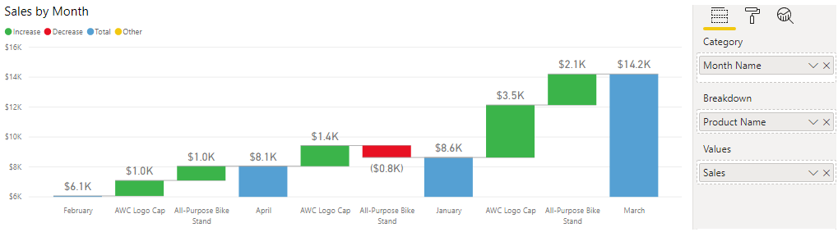
Waterfall charts can be used to:
- Visualize changes over time or across different categories
- Audit the major changes that contribute to the real value
- Plot your organization’s annual profit by showing various sources of revenue to help determine the total profit
- Illustrate the beginning and ending headcount for your organization in a year
- Visualize how much money you earn and spend each month and the running balance for your account
Scatter Chart
effective when you are comparing large numbers of data point without regard to time

An example is shown below:
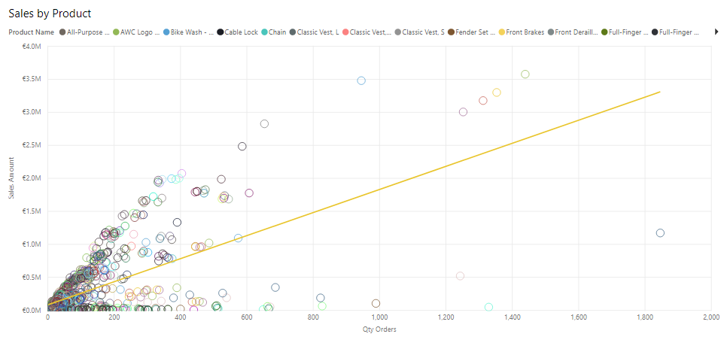
The above scatter chart displays outliers (anomalies) with a trendline going up.
The chart shows that most products were sold at the same quantity, and only some products were sold in larger quantities.

The charts displays points at the intersection of an X and Y numerical value, and combining these values into a single data point

Scatter charts allow you to:
- Show relationships between two numerical values
- Plot two groups of numbers as one series of x and y coordinates
- Turn the horizontal axis into a logarithmic scale
- Display worksheet data that includes pairs or grouped sets of values
- Show patterns in large sets of data, e.g., by showing linear or non-linear trends, clusters and outliers
- Compare large numbers of data points without regard to time.
  - THE MORE data you include in a scatter chart, the better the comparisons you can make

Maps
Power BI integrates with Bing maps to provide default map coordinates (a process called geocoding)

A basic map is used to associate categorical and quantitative information with spatial locations

A fill map uses shading, tinting, or patterns to display how a value differs in proportion across a geographical region.

A shape map uses colours to display relative comparisons of geographical regions

You can also use ArcGIS map to display graphical information in a more interactive way

Slicer Visualization
A stand-alone chart that can be used to filter the other visuals on the page.

Slicers provide a more advanced and customized way of filtering, in comparison to the Filters pane, which is suited to more basic filtering operations

Slicers come in many different formats:
- list
- drop-down
- buttons

They can be formatted to allow the selection of only one, many, or all available values

Slicers are ideal to:
- Visualize commonly used or important filters on the report canvas for easier access.
- Simplify your ability to see the current filtered state without having to open a drop-down list
- Filter by columns that are unneeded and hidden in the data tables
- Create more focused reports by putting slicers next to important visuals

GIANT NOTE:
Using a slicer that is set to a drop-down format will defer the queries that are being sent to the database and can help performance

An example of a list, drop-down, and button Slicer is shown below:

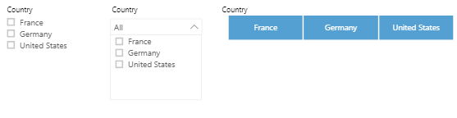
Q&A Visualization
Allows you to ask natural language questions and get answers in the form of a visual.

This ability to ask questions is valuable to consumers and you

This visualization type can help you create visuals in the report and it can also be used as a tool for consumers to get answers quickly

The Q&A visualization consists of the following four components:
- question box
  - where users enter their question and are shown suggestions to help them complete the question
- A pre-populated list of suggested questions
- An icon that users can select to convert the Q&A visual into a standard visual
- An icon that users can select to open Q&A tooling
  - which allows designers to configure the underlying natural language engine

The following example illustrates how to implement Net Sales by Country through a Q&A visualization:

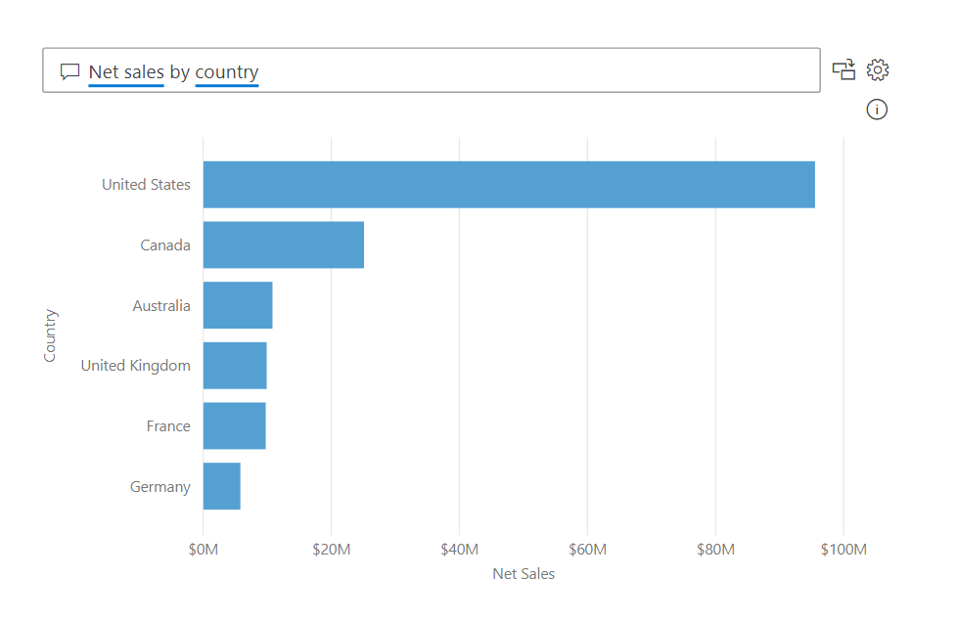
Format and Configure Visualizations
Power BI gives you a variety of options for customizing how your selected visualization looks

e.g., colours and format of the text they contain

We can format the visualization by selecting the visualization on the Canvas
=> then select the Format button (paint roller icon)
=> Power BI then displays the Format pane

An example is shown below:

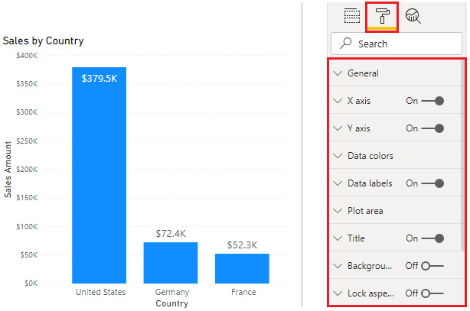

Common formatting options include:
- Title
- Background
- Border

Title
In this section, you can:
- add a title to the visual
- edit the title
- format the title – changing the text, text size, font, colour, background, and alignment

the example below depicts a visual having its title changed, and the font size increased to 16 points

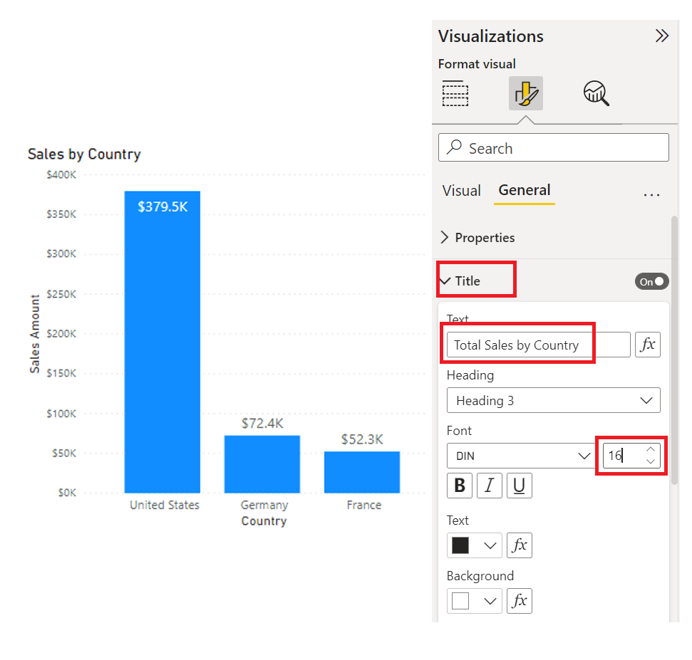
Background
In this section, you can:
- set any colour or image as the background for the visual
  - If an image is being selected, avoid images with lines or shapes as it might make it difficult for users to read the data
  - best to keep a white background, so that the presented data can be seen easily

The below example is a depiction of a visual having its background colour changed to light grey
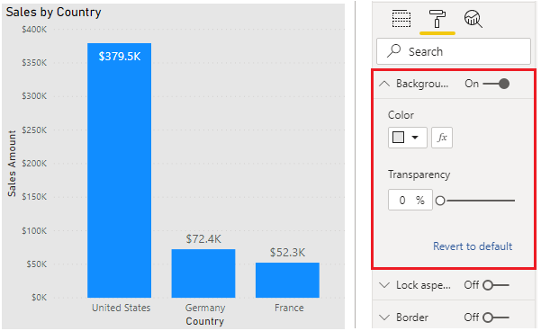

Border
In this section, you can:
- Set a border around the visual to isolate the visual from other elements on the Canvas
- Change the border colour and radius to be consistent with your colour scheme

General
If this section is available, you can:
- set the precise size and place for your visual on the Canvas
- useful to ensure that you have aligned specific visuals consistently

Data Colours
In this section, you can:
- format the colours and labels for specific data
- set the colours that you want to use for the data values in the visual
  - NOTE: you should stick to the general colour scheme throughout the report
- change fonts, size, and colours for all labels in the visual
- try to use solid colours so that the labels are clearly visible

Tooltips
In this section, you can:
- add a customized tooltip that appears when you hover over the visual, based on the report pages
  - Tooltip is a great feature as it provides more contextual information and detail to data points on a visual
  - The default tooltip displays the data point’s value and category, but your custom tooltips can include visuals, images, and any other collection of items that you create

You can also drag columns and additional data points into the tooltips
This allows user to see the value when they HOVER OVER THE VISUALIZATION
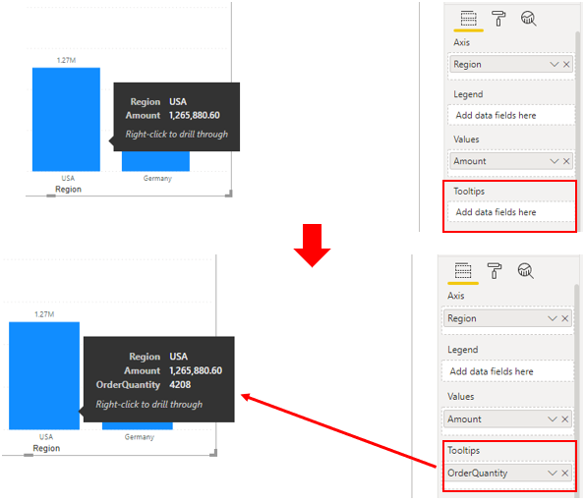

***Another method of using tooltips is to display graphical information

YOU SHOULD LEARN THIS SECTION

Begin by, creating a new page in the report
=> Open the new page and then, open the Format pane
=> Expand the PAGE SIZE section, and then select Tooltip from the Type list

The steps are illustrated below:
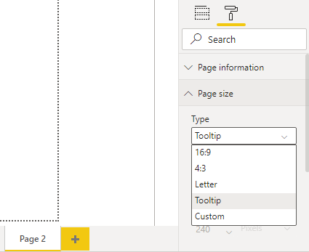

In the Page information section, turn the Tooltip slider to On so that Power BI registers this page as a tooltip page, this is illustrated below
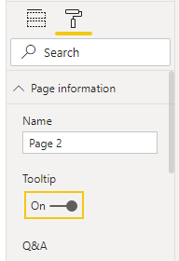

Tooltips have limited canvas space, to ensure that your visuals appear in the tooltip, on the View tab (top ribbon of the page), set the Page view option to Actual size

Next, add one or more visuals IN THE TOOLTIP PAGE
=> Next, specify the fields for which you want the tooltip to display
=> Select the tooltip page and then select the Values tab in the Visualizations pane.
=> Drag the fields from the Fields pane into the Tooltip bucket

an example is shown below:
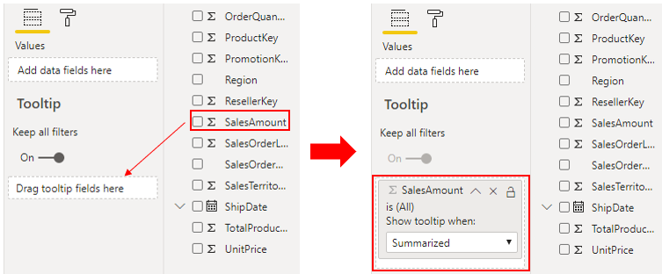
Return to the report page, and then apply the tooltip to one or more visuals on that page.

Select a visual and then in the Format pane, scroll down to the Tooltip section
=> Turn the tooltip option On and then select your tooltip page from the Pages list

When you hover over the visual, the tooltip will display, as shown in the illustration below:
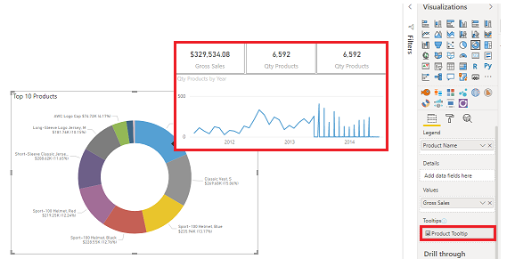
Import a Custom Visual
If you have a specific visual in mind that is NOT AVAILABLE in the current offerings, then you can likely find it in the MARKETPLACE

Power BI also grants you the ability to build your own visual

NOTE: CUSTOM VISUALS MUST BE IMPORTED From AppSource EACH TIME YOU START DEVELOPING A NEW REPORT

Custom visuals are available in Microsoft AppSource

Some of these custom visuals are certified and some are not certified
Certified Visuals
This status means that the visual meets the Microsoft Power BI team code requirements

The visual is tested to verify that it doesn’t access external services or resources and that it follows secure coding patterns and guidelines

Uncertified Visuals
Certification of visuals is optional

Therefore an uncertified visual is not necessarily unsafe to use

Creating Your Own Visual
If you want to create your own custom visual, you can use the:
- custom visual software development kit (SDK)
  - An open-source tool based on NodeJS (JavaScript programming language)
  - Custom visuals are packaged as a single Power BI visual tools (.pbiviz) file
  - You can import it into Power BI desktop

Importing a Custom Visual From App Source
In the Visualization pane, select the Get more visuals icon and then select Get more visuals
=> On the window, locate, and select the visual that you want to import and select Add

This process is illustrated below:
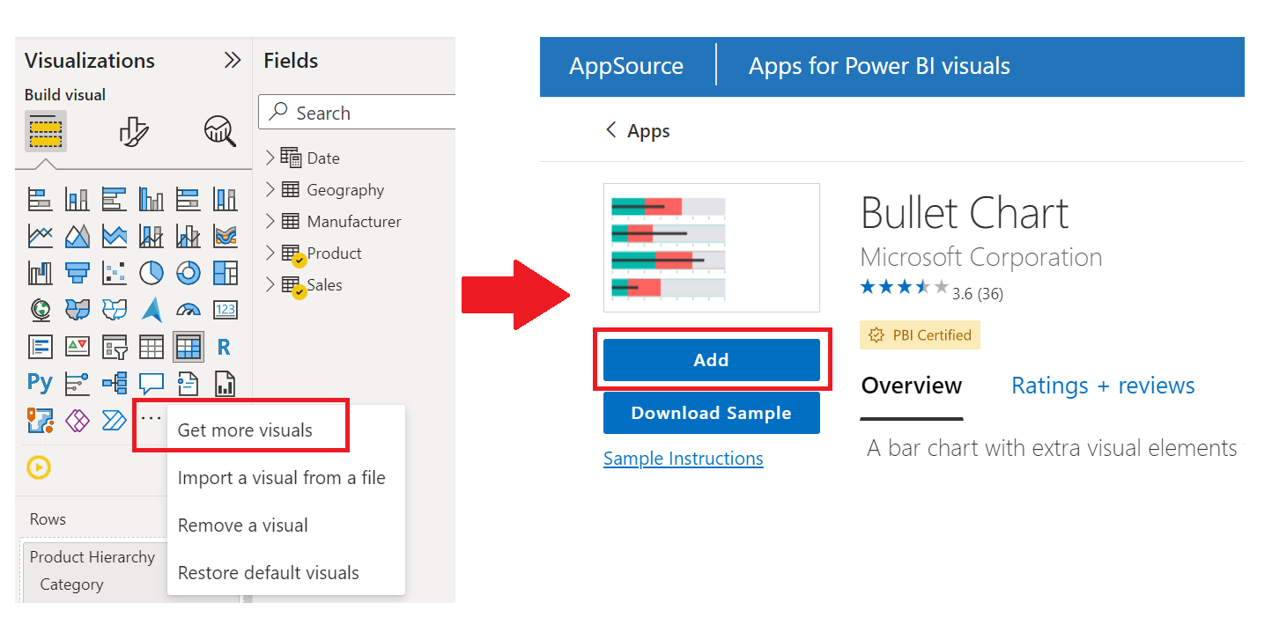
The visual will now appear on the Visualization tab pane along with every other Visualization
=> to add the visual to the report, select its icon
=> you can then add fields to visual and customize its formatting, like every other visual

The process is illustrated below:

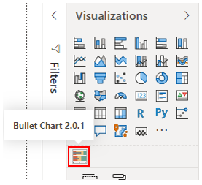

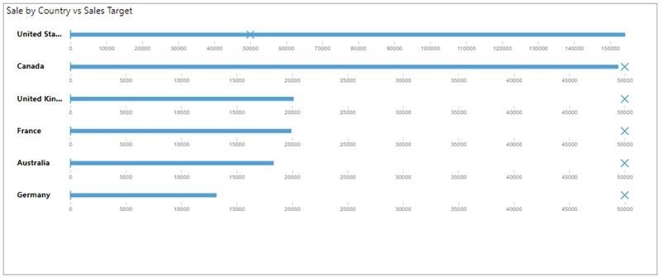
Add an R or Python Visual
Power BI grants the ability to use out-of-the-box visualization options for both R and Python that you can access on the Visualization pane

Create an R Visual
In order to create an R visual, you must have R installed in your local computer

Select the R visual icon in the Visualizations pane and then select Enable on the window that displays.
=> You’ll then see a placeholder R visual image on the report canvas, with the R script editor underneath

This process is illustrated below:
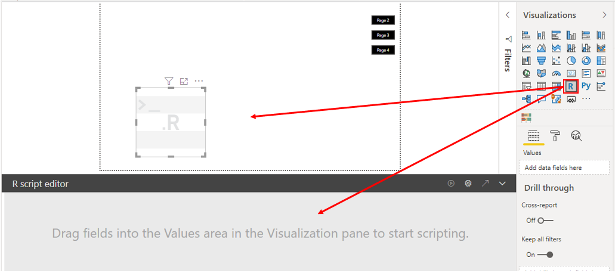

As you select or remove fields and add fields used in the fields the supporting code in the R script editor is automatically generated or removed. Based on your selections, the R script editor generates the following binding code:
- The editor created a dataset data-frame with the fields that you added
- The default aggregation: do not summarize
- Similar to table visuals: fields are grouped and duplicate rows appear only once

When you have selected the fields, write the R script that results in plotting to the R default device. When it is completed, select Run from the R script editor title bar

The process is further illustrated below:
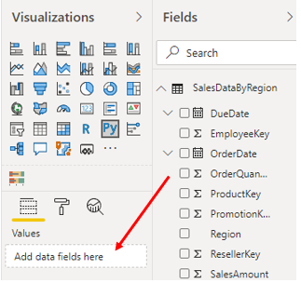

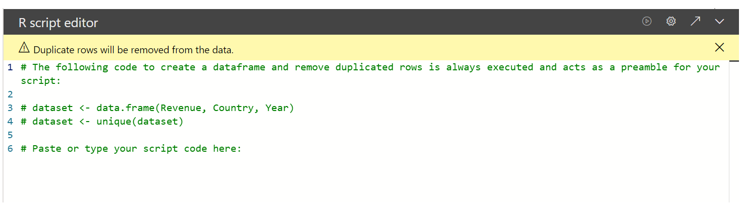
Create a Python Visual
NO PRE-REQUISITES EXISTS for creating a Python visual, so you can start right away the process is similar to the R visual and is best to be illustrated as seen below:
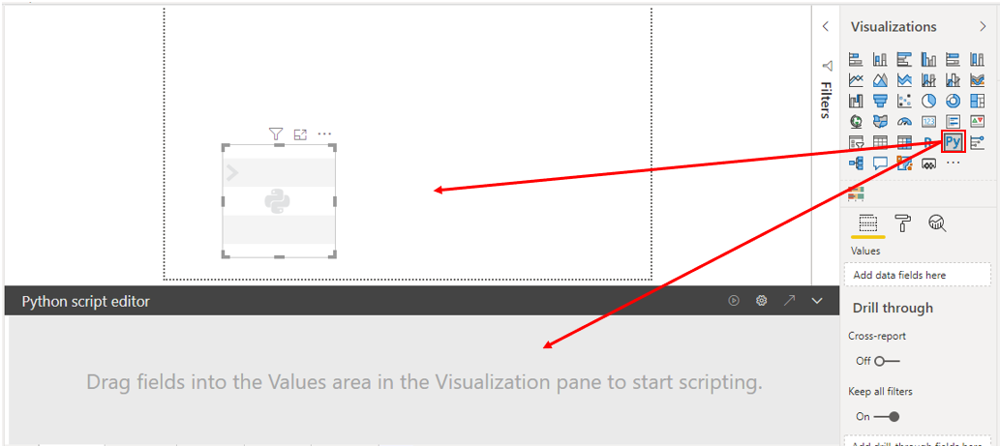
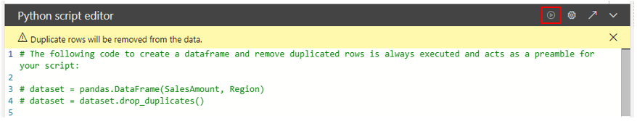
Import an R or Python Visual
To import an R or Python Visual from AppSource

Firstly, in the Visualization pane, select the Get more visuals icon and then select Get more visuals
=> On the window that displays, select the R or Python visual that you want to import and then select Add

The process is illustrated below
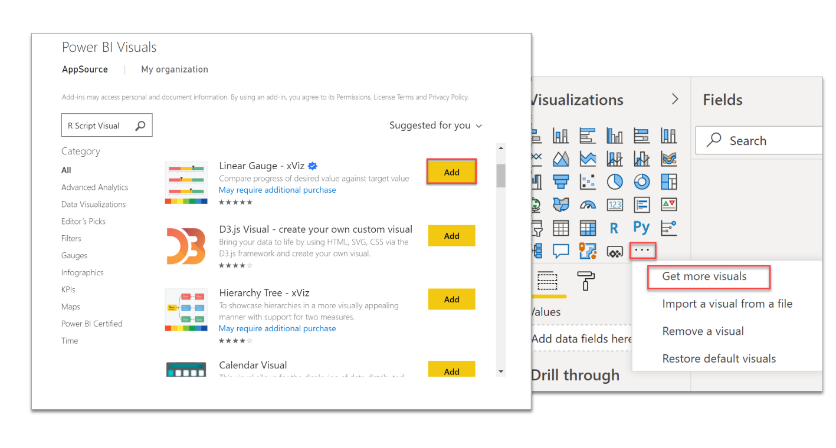
***Work with Key Performance Indicators
Key performance indicators (KPIs) are excellent in helping you track progress towards a specific goal over time

In order to use KPIs, you need three pieces of information:
- A unit of measurement that you want to track
  - e.g.,
    - instance total sales
    - number of employee hires
    - number of loans serviced
    - number of students enrolled
- A goal for the measurement so that you can compare your progress with that goal
- A time series, for instance, daily, monthly, or yearly

you can select KPIs by clicking the KPI icon in the Visualizations pane, as shown below:
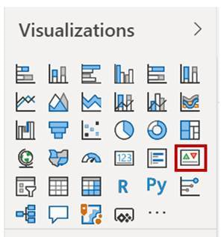

When configuring KPIs, enter:
- the unit of measurement that you are tracking in the Indicator prompt
- the goal under Target goals
- select the time series from the Trend-axis drop-down list
This is depicted in the image below:
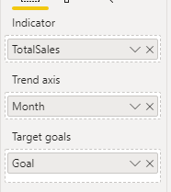

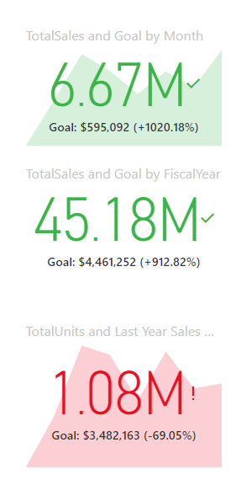
KPIs work best in a series, e.g., showing the daily, monthly, and yearly goals in the section of a Power BI report, as shown below.

